FOREWORD
Dear Reader,
Abridged version of the 2009 Annual Report of the Tax Administration of Republic of Srpska (RS) provides the summary of the most significant achievements in the past year.
Despite the effects the global economic crisis has had on the RS fiscal system we are satisfied with our results, primarily in terms of the Tax Administration’s main task, i.e. collection of public revenues, which fall under the competence of the RS Tax Administration.
Throughout 2009 we have attempted to provide for full transparency of our operations and have used communication with taxpayers and the media to inform the public about our achievements.
The report on our 2009 results is made public and available to our taxpayers and all other interested parties, whereas our employees can use it as a solid base for analysis, as well as the means for more efficient work organization in the forthcoming period.
Banja Luka, January 2010


Acting Director
Tax Administration of Republic of Srpska
Mile Banika

TABLE OF CONTENTS:
I DEFINITIONS AND ABBREVIATIONS 3
II LEGAL FRAMEWORK 4
III ORGANIZATION OF THE RS TAX ADMINISTRATION 5
IV HUMAN RESOURCES 7
V TAXPAYER TREATMENT 8
VI MAJOR WORK RESULTS OF THE RS TAX ADMINISTRATION 10
1. Collection of public revenues 10
1.1. Social Insurance Funds’ revenues 11
2. Receiving and processing tax returns 13
3. Audits, Investigations, and Intelligence 14
3.1. Audit 14
3.2. Minor Offence Procedure 15
3.3. Decision documents for payment of reported due liabilities 16
3.4. Investigations and Intelligence 16
4. Internal Audit 17
5. Tax certificates issued to taxpayers 17
6. Enforced Collection 18
7. Agreements on extended payment of debt 18
7.1. Agreements on debt reschedule in line with RS Government Decisions 18
7.2. Agreements on extended acquaintance in line with the Article 75 of the Law on Tax Administration of RS 19
8. Specific Procedures 19
8.1. Bankruptcy Procedures 19
8.2. Liquidation 19
8.3. Insolvency 19
8.4. Uncollectible liabilities 20
9. Tax Appeals 20
10. Refunds, Transfers, and Corrections 20
11. Information Technologies 21
12. Cooperation with other institutions/agencies 22
13. Media Appearance 23
VII SUMMARY 24

- DEFINITIONS AND ABBREVIATIONS
TARS – Tax Administration of Republic of Srpska
TIN – Taxpayer Identification Number
TPC- Taxpayer Card
KOR – Application used for entry of corrections following ex officio procedures
KUP – Application used to monitor taxpayer audit procedure
PN – Application used for management of enforced collection procedure
DRPN – Application used for management of changes to the enforced collection deposit account
FISKAL – Support system for fiscal cash register process
USAID - United States Agency for International Development
USAID TARA –Tax Reform Activity
USAID ELMO –Project for Enabling Labor Mobility
IОТА – Intra-European Organization of Tax Administrations
SUFI – System for Financial Information Management
CAMA Model – Computer-Assisted Mass Appraisal Model
KUF – Incoming Invoice Log
PFRN – Registration form for Fiscal real Estate Register
ZUPO – Request for Real Estate Tax Base Reduction
ECDL - European Computer Driving Licence
SKIOP – Audit, Investigations, and Intelligence Sector
KM - Convertible Mark
- LEGAL FRAMEWORK
The Republic of Srpska Tax Administration was established in line with the Law on Tax Administration of Republic of Srpska (“Official Gazette of RS“ No: 51/01), in effect as of 24 October 2001, which is governing the basis for implementation and pursuance of tax laws and bylaws in Republic of Srpska, and defining tax related minor offences, crimes, and respective sanctions. The Law defines tax as any payment to the Budgets of Republic of Srpska, cities, municipalities and funds, which shall be rendered under tax laws, laws on contributions and laws on fees, as well as pursuant to other laws prescribing charges, which is compulsory, non-repayable and not made in exchange for a specific type of goods or services.
This Law replaced several other laws such as the Law on Audit, Assessment, and Collection of Public Revenues and the Law on Financial Police, and established a new tax agency as an integral part of the RS Ministry of Finance.
The Law on Tax Administration constitutes the legal framework defining the scope of work, organization, method of work, and management of RS Tax Administration, as well as its mandate and responsibility in regards to tax collection and records, and safety and confidentiality of collected information.
Law on Tax Administration of Republic of Srpska (Official Gazette of RS“, No. 112/07 – consolidated text, No. 22/08, and No. 34/09)
To that respect, Tax Administration implements fiscal policy and collects taxes and other public revenues within its competence, in line with tax related laws and international agreements; it provides assistance to taxpayers in fulfillment of their tax obligations; monitors and analyses the functioning of the fiscal system; makes proposals aimed to enhance the fiscal system in RS; cooperates with other state bodies, institutions, and organizations; delivers reports to external users; and provides legal assistance to international bodies in resolving tax related cases.
The Law on Tax Administration regulates tax policy and administrative procedure, tax assessment procedure, audit, public revenue collection, taxpayers’ rights and obligations, enforced collection, tax appeals, and minor offence procedure. Several bylaws and rulebooks have been issued in support of consistent implementation of the Law.

- ORGANIZATION OF THE RS TAX ADMINISTRATION
The Tax Administration of Republic of Srpska, as a body incorporated within the RS Ministry of Finance, is charged with a primary task to consistently, efficiently, and impartially collect public revenues.
Our Mission......
Tax Administration’s main task is to consistently, impartially, and efficiently collect public revenues thus providing service to both, the Republic of Srpska and its citizens.
In accomplishing this task, Tax Administrating must steer by the following principles:
- Integrity,
- Legality,
- Impartiality,
- Reliability.
Our Vision.....
RS Tax Administration, being in charge of collection of public revenues and implementation of legislation, and acting as service to taxpayers, shall continue to consistently, efficiently, and impartially implement all laws pertaining to its scope of work and improve the quality of services provided to taxpayers, including the provision of timely information to the public on all current affairs of the Tax Administration.

RS Tax Administration Head Office is in charge of coordination, surveillance and control over operations and unified implementation of tax policy, and to that extent, the provision of professional assistance and education to employees at all organizational levels.
The Rulebook on Internal Organization and Systematization of Positions in RS Tax Administration (“Official Gazette of RS“, No: 66/09), established the following, basic organizational units: Head Office, Regional Centers, Local Offices, and Temporary Offices.
The Head Office incorporates the following organizational units:
  - Department for Organization of Work, Plan and Analysis, International Relations, and Public Relations,
  - Internal Control and Internal Audit Division,
- Audit, Investigations, and Intelligence Sector,
- Tax Collection Management Sector,
- Taxpayer Service Sector,
- Information Technologies Sector,
- Central Tax Documentation Processing Sector,
- Human Resources Sector, and
- Common Affairs Sector.
Regional Centers incorporate the following organizational units:
- Department for Taxpayer Service, Audit, and Collection,
- Department for Legal and Administrative-Technical Affairs,
- Local Offices, and
- Temporary Offices.
RS TAX ADMINISTRATION ORGANIZATIONAL STRUCTURE
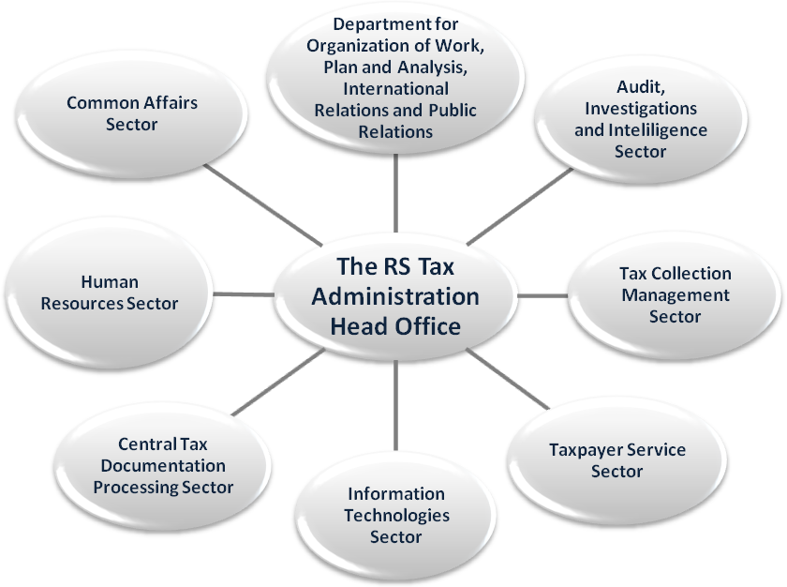

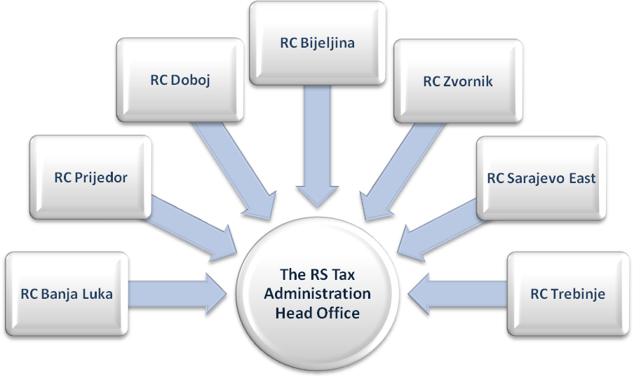

- HUMAN RESOURCES
Human resources constitute the most important factor in any organization, including the RS Tax Administration. Their creativity, innovativeness, motivation, level of information, and other qualities are the driving force behind success of the organization.

…Quality of human resources is the measure of success of any organization...

Political Neutrality
Political neutrality implies professional and politically wise impartial performance of employees, free of own political views.

Independence
Professional independence of employees is to be provided in order to protect the legality and objectivity of their work.

Conflict of Interest
Tax officers are not to use their position to gain personal benefit and are to avoid all situations that might result in conflict of interest and detriment to Tax Administration’s reputation.

Tax Secret
Tax officer must treat data and information obtained through work as professional secret. In addition, pursuant to the Law on Tax Administration (Article 9) s/he is obliged to provide information as per request of specific institutions.
Having realized that without quality staff there will be no further progress of operations, RS Tax Administration has organized numerous educations and trainings for employees in 2009 in an attempt to improve efficiency at work and fulfill the planned tasks and activities.
In addition, RS Tax Administration took part in the RS Government project for employment of university degree interns, and hence employed 8 interns in 2009, thus giving them an opportunity to gain experience and fulfill the conditions for taking professional exam required for employees in public administration. TARS employees had the possibility to expand their knowledge and exchange experiences in various fields of tax policy through seminars, educations, workshops, and other similar events.
The number of employees in TARS, as of 31/12/2009, is 775, whereas their educational structure is as follows:
- 428 with university degree (VSS),
- 79 with postsecondary degree (VŠS),
- 5 highly skilled workers (VKV),
- 231 with secondary degree (SSS),
- 22 qualified workers (KV),
- 8 semi-qualified workers (PK), and
- 2 non-qualified workers (NK).
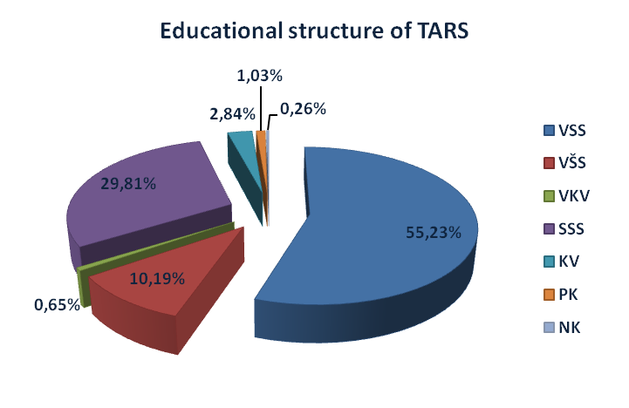
- TAXPAYER TREATMENT
Providing timely information to taxpayers regarding the changes to current regulations and new legislation constitutes one of primary activities of Tax Administration, with the aim to boost voluntary compliance and self assessment, which in turn, means less administrative and other costs for Tax Administration.



2009
TAX CALENDAR

www.poreskaupravars.org
e-mail:
kontakt@poreskaupravars.org
call centre:
+387 51 345 080
Therefrom, voluntary compliance constitutes a key feature of the tax system. Higher level of voluntary compliance reduces the cost of collection, but, on the other hand imposes an obligation for the Tax Administration to strengthen its role as the service to taxpayers. For that reason, we have made it possible for taxpayers to access TARS services and assistance in different ways. In 2009, we have registered the following rate of taxpayer contact:
Throughout 2009 we have been working to improve the quality of services provided to taxpayers, the proof of which was demonstrated in the fact that our web site, www.poreskaupravars.org, was proclaimed the best web site in 2009 in the “public administration” category as a part of the traditional selection of the best “web portals” in BiH. In 2009, we had 295.157 hits on our web site, which is by 59% more relative to 2008. Through our web site, taxpayers were able to obtain all relevant tax related information.
Contacts with taxpayers | 2009 | 2008 | Index
Direct contact | 959 | 838 | 114
Telephone | 19.363 | 11.396 | 170
E-mail | 1.546 | 990 | 156
Call center | 63 | 178 | 35
Correspondence | 512 | 436 | 117
Thematic meetings | 8 | 8 | 100
Seminars for taxpayers | 1 | 1 | 100
The most frequently asked questions coming from taxpayers in 2009 were pertaining to corporate income tax, personal income tax, contributions, fees, and real estate tax issues. In regards to the latter, Tax Administration has invested significant efforts to promote the establishment of the Fiscal Real Estate Registry, considering the interest expressed by taxpayers to register their real estate. We have also organized several thematic meetings with target groups, with the aim to inform taxpayers about tax regulations and possibilities which we render to enable easy compliance.
At the beginning of 2009 we have designed and distributed the Public Invitation to file tax returns, as well as tax calendar for legal entities, entrepreneurs and natural persons.

Through quality taxpayer service, RS Tax Administration strives to raise awareness of taxpayers with respect to the functioning of the tax system.

Taxpayers registered in 2009:
Citizens 70.570
Legal Entities 3.436
Entrepreneurs 3.512
*Other 2.734

Taxpayers deregistered in 2009:
Citizens 1
Legal Entities 2.273
Entrepreneurs 2.194
*Other 449

In the period 01/01-31/12/2009, Tax Administration registered 80.252 new taxpayers, whereas 4.917 taxpayers were deregistered.
Breakdown as of 31/12/2009 shows Tax Administration provided service to 1.197.457 registered taxpayers, including:
  - 1.109.064 citizens,
  - 36.604 legal entities,
  - 43.279 entrepreneurs, and
  - 8.510 other*.
*Branch offices of legal entities from FBiH and Brcko District, foreign business and consular offices, expatriates, nonresidents, entities deregistered in line with ex officio procedure

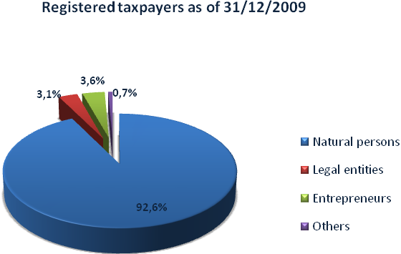

- MAJOR WORK RESULTS OF THE RS TAX ADMINISTRATION
- Collection of public revenues
The total of 1.818.444.988 КМ was collected via public revenue account for the period 01/01-31/12/2009, out of which 1.806.507.605 КМ in direct taxes. Additional 34.334.445 КМ were collected via internal debt bonds. Relative to 2008, collection of public revenues was increased by 5%, nonetheless, if compared against the plan for the period, the collection rate was lower by 2%.
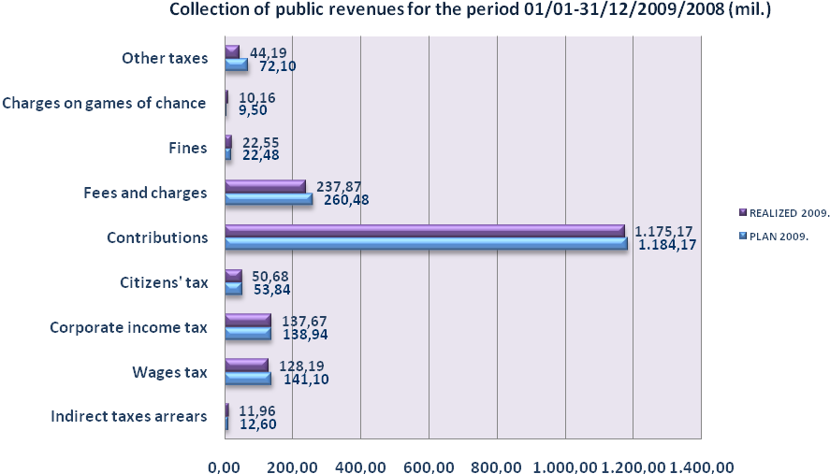
Relative to the same period in 2008, collection of direct taxes was higher in contributions (15%), corporate income tax (16%), fines (8%), as well as in terms of charges collected for organization of games of chance, i.e. 14%, which is in part a result of the new Law on Games of Chance issued in 2008. We expect to see more effects of this Law in 2010.
On the other hand, collection of the following taxes was lower relative to 2008: citizens’ taxes (32%), wage tax (25%), fees and charges (10%), and other taxes (20%).
Reasons to lower collection rate of public revenues are seen in the fact that global economic crisis had a direct, negative impact on the volume of business operations, investments, consumption, and lay offs, the end result of it being the lower rate of GDP growth. In addition, the Personal Income Tax Law was changed, i.e. the nontaxable portion of income was raised from 250 KM to 300 KM, and the rate of tax was reduced from 10% to 8%, which in part contributed to lower collection results in terms of wage tax.
When it comes to Regional Centers’ (RC) share in the structure of collected pubic revenues the situation is as follows: RC Banja Luka 45,79%, RC Prijedor 7,21%, RC Doboj 11,55%, RC Bijeljina 12,73%, RC Zvornik 5,05%, RC Sarajevo East 8,67%, RC Trebinje 7,98%. Additional 1,02% were collected at the territory of Brcko Dstrict (portion of source revenues of RS, i.e. contributions).
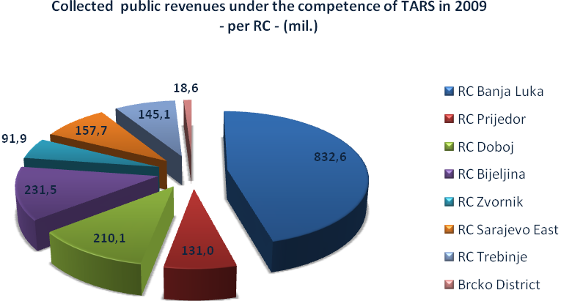
Out of 1.818.444.988 КМ collected public revenues under the competence of RS Tax Administration, 380,64 million КМ were allocated to the Single Treasury Account by 31/12/2009 as revenues of the RS Budget.
  - Social Insurance Funds’ revenues
Tax Administration of Republic of Srpska is in charge of accounting and collection audit for contributions used to finance pension and disability insurance, health insurance, unemployment insurance, and child protection in Republic of Srpska. As of 20/03/2009 TARS is in charge of collection of contribution for employment of disabled persons. Payments for this particular contribution are made via RS Public Revenue Account in line with the new Order on payment of specific revenues of the Budget of RS, municipalities, cities, and funds.
The total of 1,18 billion KM was collected in social contribution funds in 2009. Relative to the same period in 2008, collection increased by 15%, i.e. 156 million KM, with the largest percentage of increase recorded in health contribution (28% more than in the same period of 2008). The pension fund contribution collection was higher by 8%, employment contribution by 7%, and child protection by 5% relative to the same period a year earlier. As for the contribution pertaining to employment of disabled persons, 1.031.352 КМ were collected in the period 20/03-31/12/2009.
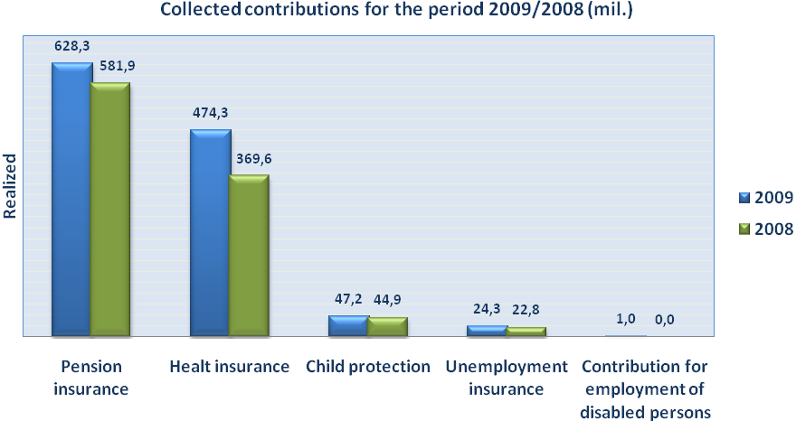
Actual collection of contributions, relative to 2009 Plan, was 99%. Health insurance contribution collection was higher by 6% relative to plan, whereas pension and disability insurance contribution collection was lower by 5%. employment and child protection contribution collection was lower by 3%.
Fund | Plan 2009 | Realized 2009 | Index
Pension Fund | 662.555.994 | 628.295.634 | 95%
Health Insurance Fund | 448.000.000 | 474.316.685 | 106%
Child Protection Fund | 48.550.000 | 47.210.346 | 97%
Unemployment Insurance Fund | 25.067.000 | 24.319.366 | 97%
Employment of Disabled Persons Fund | 0,00 | 1.031.352 | -
Total | 1.184.172.994 | 1.175.173.383 | 99%
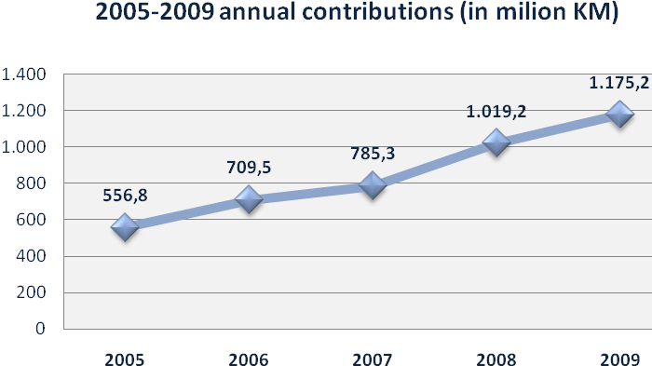
- Receiving and processing tax returns
Law on Tax Administration introduced the self assessment principle. Respectively, taxpayers are legally obliged to report their liabilities in line with the procedure and deadlines prescribed under tax laws.

In 2009, the Central Tax Documentation Processing Sector received 1.046.759 tax returns.
Planned level for receiving tax returns was realized at the rate of almost 100%, whereas 1,2% more tax returns were scanned relative to plan.
Moreover, 1.101.588 tax returns have been subject to control, which is by 8,87% more relative to 2008, and 34,39% more than planned for the year.
 | Planned  2009 | Realized  2009 | Realized  2008 | Realized vs.  Planned (%) | 2009 vs.  2008  (%)
TR Received | 1.050.000 | 1.046.759 | 1.030.370 | 99,69 | 101,59
TR Scanned | 1.050.000 | 1.062.809 | 1.012.948 | 101,22 | 104,92
TR Controlled | 820.220 | 1.101.588 | 1.011.832 | 134,30 | 108,87
We have introduced the possibility for taxpayers to file their monthly withholding tax returns (MPO-1002) electronically. This application resulted in less manual work in terms of entry and scanning of tax returns.
To expand the size of taxpayer population using e-filing system for monthly withholding tax, the Central Tax Documentation Processing Sector has, in June 2009, jointly with the Information Technologies and Taxpayer Service Sectors, organized a presentation on “Method and advantages of e-filing for monthly withholding tax returns” for 60 budgetary beneficiaries (Ministries, educational institutions, courts, public attorney offices, and other administrative bodies and organizations in RS).
In the period 01/01-31/12/2009, 99.955 monthly withholding tax returns were filed electronically, i.e. for the sum of 149.527.948,22 КМ in income tax (65,93% relative to the total sum of reported income tax), and additional 1.005.995.015,10 КМ in contributions (62,98% relative to the total sum of reported contributions).
In 2009, we have also initiated the activity of registration of real estate with the Fiscal Real Estate Register. The Register data will be used in appraisal of market value of immovable property. The new Real Estate Tax Law, which will be in application as of January 01, 2012, introduces the ad valorem basis of taxation, whereby actual market value of real estate will constitute the basis for taxation. The Computer-Assisted Mass Appraisal Model (CAMA Model) will be used to assess the market value of real estate.
- Audits, Investigations, and Intelligence
- Audit
There were 1.668 field audits in total for the period 01/01-31/12/2009.
Total due liabilities ordered for payment as per Tax Administration’s decision documents, issued in field audits in the same period, were 57,59 million КМ. Out of that amount, taxpayers have already reported 19,39 million КМ, but failed to pay, whereby additionally assessed tax liability was 38,20 million КМ.
Only 6,83 million KM, or 11,86% of the total assessed liabilities in field audits were paid within the voluntary period (10 working days).
Following field audits, Tax Administration’s auditors have filed 150 minor offence warrants and 21 minor offence reports due to irregularities identified in taxpayers’ operations. 102 appeals have been filed against Tax Administration’s decision documents. These minor offences pertain to decision documents on payment of due liabilities issued in the process of field audits.
In 1.104 field audits, i.e. 66% of the total number, irregularities were identified.
Relative to the same period in 2008, 315 more field audits were conducted in the period enveloped by this report, whereas the amount of liabilities paid within the voluntary period was higher by 1,18 million КМ. The field audit plan was exceeded by 22%.
2.665 desk audits were performed in 2009. Total assessed liabilities ordered for payment as a result of these audits amounted to 4,25 million КМ. Out of that amount, inspectors have assessed additional 3,57 million KM taxes, wherefrom taxpayers have reported 16,11% themselves, still due for payment. Only 377.890,09 КМ or 8,89% of the total was paid within the legally prescribed 10-day deadline.
There were 15 desk audits less, relative to the same period in 2008, and, consequently, 1,33 million KM less were paid in.
# | Type of Audit | Number of Audits |  |  | Plan realization % | Index  2009/2008
# | Type of Audit | 2009 Audit Plan | 2009 Actual Audits | 2008 Actual Audits | Plan realization % | Index  2009/2008
1. | Field Audits | 1.370 | 1.668 | 1.353 | 122% | 123
2. | Desk Audits | 3.043 | 2.665 | 2.680 | 88% | 99
 | TOTAL AUDITS | 4.413 | 4.333 | 4.033 | 98% | 107

Inspectors have audited 28.142 registrations of fiscal cash registers (“fiscalization” process). This number includes other activities pertaining to fiscal cash registers, such as module replacement, deregistration, station replacement, change of address, and such like. The fiscalization dynamics control showed that 3.988 audits were performed, which is 35% more than planned for 2009. In addition, 3.697 audits were performed pertaining to registration of sales via fiscal cash registers, which is 1% above the 2009 Plan.
2009 Fiscalization Dynamics
# | Type of Audit | Number of Audits |  | Plan realization %
# | Type of Audit | 2009 Audit Plan | 2009 Actual Audits | Plan realization %
1. | Registration of fiscal cash registers | 11.695 | 28.142 | 241%
2. | Fiscalization dynamics control | 3.210 | 3.998 | 125%
3. | Audit of registration of sales via fiscal cash registers | 3.677 | 3.697 | 101%
 | TOTAL (1+2+3) | 18.582 | 35.837 | 193%
Taxpayers filed 13.188 initial fiscalization requests (IFR) in 2009, and 18.202 decision documents on approval were issued respectively. Since the start of the fiscalization process in Republic of Srpska, in November 2008, until 31/12/2009, 40.347 initial fiscalization request have been filed, and 39.678 decision documents issued.
Filed and approved IFRs as of 31/12/2009
 | B.Luka | BIjeljina | Doboj | Zvornik | Prijedor | Sarajevo E. | Trebinje | Total
Fiscalization requests | 17.616 | 5.474 | 5.108 | 2.571 | 3.772 | 3.333 | 2.473 | 40.347
Approvals | 17.162 | 5.410 | 5.088 | 2.558 | 3.730 | 3.271 | 2.459 | 39.678
Performance level | 97,42% | 98,83% | 99,61% | 99,49% | 98,89% | 98,14% | 99,43% | 98,34%
- Minor Offence Procedure
3.064 minor offence warrants were issued in 2009 in reference to all procedures arising from the Law on Tax Administration of RS, with penalties stated in the amount of 2,17 million KM. Out of that number 1.414 warrants were accepted, and 607.283 KM were collected (544.252 KM within legal deadline and 63.031 KM through enforced collection). 115 requests have been field to initiate the minor offence procedure.
Relative to 2008, the number of minor offence warrants was higher by 2.419, 515.568 KM more were collected within the legal deadline, and there were 2 minor offence reports less than in 2008.
Fiscalization audits in 2009 have resulted in 691 minor offence warrants with penalties stated in the amount of 539.090 KM (129 warrants for legal entities in the amount of 258.000 KM, and 562 warrants for responsible parties in the amount of 281.090 KM).
In addition, audit of registration of sales via fiscal cash registers in 2009 resulted in 2.025 minor offence warrants having been issued with penalty amounting to 1.417.000 KM (268 warrants for legal entities in the amount of 533.700 KM, and 1.757 warrants for responsible parties in the amount of 883.300 KM).
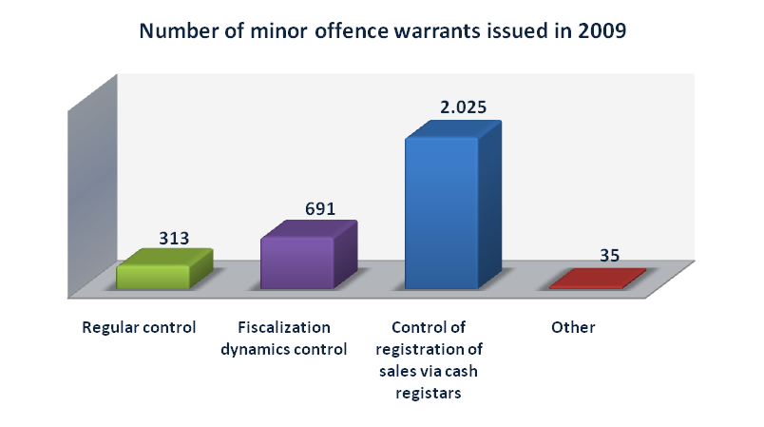
- Decision documents for payment of reported due liabilities
In 2009, 6.002 decision documents were issued on payment of reported, due liabilities (102 decision documents in average per staff member) in the amount of 43,07 million KM. Out of that amount 7,55 million KM or 17,54% were paid within the legal 10-day deadline. In addition, 1,23 million KM were paid in line with decision documents issued in the preceding period.
1.206 more decisions documents were issued than in 2008, whereas the amount paid in line with these documents was higher by about 1,36 million KM relative to the same period.
- Investigations and Intelligence
Investigations
Throughout 2009 inspectors-investigators have worked to investigate facts and collect evidence on potential, tax related offences and criminal acts.
Out of 14 reports, in tota,l submitted to the Prosecutor’s Office, 11 pertain to existence of reasonable doubt of criminal acts having been committed in reference to abuse of authority in companies, 2 reports pertain to reasonable doubt of criminal acts perpetrated in reference to evasion of taxes and contributions, and 1 pertaining to reasonable doubt for the case of deceit, with financial damage inflicted to RS Budget amounting to 1.120.412,93 KM. In cases where it was established that taxpayers have failed to file tax returns, 32 minor offence warrants were issued, whereas 61 warrants were issued in cases where taxpayers failed to issue fiscal cash receipt.
In Line with the Law on Administrative Procedure and the Criminal Code, 73 depositions related to audit findings were taken from suspects and witnesses in the process of audit in companies and in line with the order of the Prosecutor’s Office. In afore mentioned audits 2.054.498,20 КМ were assessed, and 998.761,75 КМ were collected during the audit process.
Intelligence
During the reporting period, inspectors engaged in intelligence affairs have been submitting information from the Taxpayer Registry, Taxpayer Cards, and other documentation as requested by the BiH Border Police, Municipal Courts, Republic of Srpska Ministry of Interior, Federation of BiH Ministry of Interior, RS Public Attorney’s Office, the SIPA (State Investigation and Protection Agency), and other bodies. Actions were also undertaken on the grounds of anonymous and other reports, and memos from the RS Inspectorate and Health Insurance Fund. 49 official notes have been prepared in total with respect to all afore mentioned actions.
According to intelligence findings, operations in several companies have been inspected where it was established that taxpayers have outstanding tax liability in the amount of 571.536,93 KM. Out of that amount 47.772,21 KM were collected in inspection process.
- Internal Audit
18 internal audits have been conducted in 2009 covering all organizational units in RS Tax Administration. 15 cases of irregular operations have been identified, while in 3 cases no irregularities were identified.
The following areas were subject to internal audit:
- initiation of minor offence procedure by authorized TA staff members due to violation of tax return filing procedure,
- legality and regularity of enforced collection process,
- adherence to prescribed procedures in the process of issuing tax certificates,
- adherence to prescribed procedures in annulment of tax liabilities,
- accuracy of information submitted by Regional Centers used in 2008 Report,
- legality of procedure for proclamation of labor redundancy in Tax Administration,
- internal audit initiated upon anonymous report submitted through the RS Ministry of Finance,
- irregularities in Tax Administration’s operations established in the Internal Audit Report of the RS Ministry of Finance,
- inconsistencies in work and conflict of interest of TARS staff,
- procedure of deregistration of businesses, promptness of liability status in official records, and promptness of data entry into KUP application.
- Tax certificates issued to taxpayers
In 2009, RS Tax Administration issued 70.769 tax certificates, out of which 60.824 certificates on paid liabilities, 9.849 certificates on current balance of liabilities, and 96 certificates issued for the purpose of liability restructuring.
The total of 20,65 million KM was collected with regards to certificates issued to taxpayers, out of which 20,29 million KM pertain to certificates issued to legal entities and entrepreneurs, and 360.275 KM to certificates issued to natural persons.
There were 2.518 less certificates issued in the reporting period relative to 2008, nonetheless the amount of tax liabilities paid in the process of issuing tax certificates was higher by 2,11 million KM. Relative to plan, there were 4.871 less certificates issued (94% against the plan).
# | Taxpayer | Number of Tax Certificates |  |  | 2009/Plan | Index  2009/2008
# | Taxpayer | 2009 Plan | 2009 Realized | 2008 Realized | 2009/Plan | Index  2009/2008
1. | Legal entities | 8.704 | 7.928 | 9.041 | 91% | 88
2. | Entrepreneurs | 5.116 | 2.542 | 4.252 | 50% | 60
3. | Natural persons | 61.820 | 60.299 | 59.994 | 98% | 101
 | TOTAL (1+2+3) | 75.640 | 70.769 | 73.287 | 94% | 97
- Enforced Collection
In line with the Law on Tax Administration, enforced collection measures were initiated for liabilities, which have been ordered for payment pursuant to decision documents issued by Tax Administration and have not been paid within the period of 10 working days following the delivery of the decision document.
In the period 01/01-31/12/2009, 11.330 enforced collections were initiated pertaining to debt amount of 70,36 million KM. Out of that amount, 8,52 million KM were collected in enforced collection in line with decision documents issued in 2009, whereas 3,52 million KM were collected in relation to decisions documents on enforced collection from 2008.
Relative to 2008, the number of initiated enforced collections was higher by 5.289, and the amount of liabilities collected in these procedures in 2009 was by 2,5 million KM, i.e. 21% higher than in 2008 (including the sum paid prior to initiation of enforced collections, following the expiration of the voluntary payment period).
Relative to 2009 plan, there were 194 more enforced collection procedures initiated, and extra 4,95 million KM were collected (the plan was exceeded by 53%).
- Agreements on extended payment of debt
- Agreements on debt reschedule in line with RS Government Decisions
36,17 million KM were collected from rescheduled debt installments due in 2009.
In the reporting period, 58 Agreements have been signed in the Tax Administration Head Office on settlement of due tax liabilities for the total amount of debt of 65,81 million KM, out of which 14 did not include a grace period. In addition, accordingly to the RS Government Decision, dated 02/11/2006, on settlement of due tax liabilities, 6 agreements were signed in 2009 pertaining to 3,88 million KM debt.
As a result of nonpayment of due installments under agreements, and nonpayment of current liabilities, the Tax Administration cancelled 14 agreements pertaining to 4,62 million KM.
The remainder of debt enveloped by all other signed reschedules amounts to 314,55 million KM, while on 31/12/2008 this amount was 310,85 million KM.
- Agreements on extended acquaintance in line with the Article 75 of the Law on Tax Administration of RS
44 Agreements on extended acquaintance of liabilities have been signed in Tax Administration in the period 01/01-31/12/2009 (Article 75 of the Law in Tax Administration), for the amount of 5,18 million KM. For 62 such Agreements (pertaining to 2009 and previous period) 2,46 million KM were collected.
Relative to 2008, the collection in line with these Agreements was lower by 721.220 KM, nonetheless, the plan pertaining to this category was exceeded by 117%.
Due to nonpayment of due installments under agreements, and nonpayment of current liabilities, the Tax Administration cancelled three agreements initially signed in line with the Article 75 of the Law on Tax Administration pertaining to 899.229 KM.
  - Specific Procedures
Throughout 2009, RS Tax Administration was engaged in activities pertaining to specific procedures, i.e. bankruptcy and liquidation. This included assessment of tax liabilities for taxpayers subject to these procedures, and reporting on initiated and completed procedures.
- Bankruptcy Procedures
For 69 taxpayers bankruptcy procedure has been initiated in 2009. Reported receivables amounted to 37.764.865,72 KM, out of which 19.991.762,48 KM were admitted.
There were no collections in connection with bankruptcy procedures initiated in 2009, while 2.357.887,25 KM were collected for previously initiated procedures.
- Liquidation
In 2009, liquidation procedure has been initiated for 283 taxpayers. The amount of reported receivables was 882.050,69 KM, out of which 841.891,04 КМ were admitted.
For liquidation procedures initiated in 2009 and in previous periods the total of 156.732,26 KM was collected.
- Insolvency
124 taxpayers were proclaimed insolvent in 2009, with 51,92 million KM of temporarily uncollectible liabilities.
TA Regional Centers have been ordered to review all insolvency decision documents, which were enforceable more than a year ago, i.e. to confirm potential solvency of the taxpayer and their related parties. In that sense, 151 draft decision documents on insolvency were reviewed in 2009.
- Uncollectible liabilities
Considering the fact that frequently not all tax liabilities can be collected in bankruptcy procedure, Tax Administration has developed a concept of decision document by which tax liabilities can be proclaimed uncollectible. All Regional Centers are to act in line with the concept.
66 decision documents were issued in 2009 on incollectibility of tax liabilities in connection with bankruptcy procedure, for the amount of 7.733.385 KM.
  - Tax Appeals
Tax Administration Regional Centers received 1.663 appeals in 2009 pertaining to all procedures in connection with the Law on Tax Administration. 122 were dismissed, 123 decision documents were replaced, and 54 procedures were amended. 1.376 appeals have been forwarded to Tax Appeals Board, out of which 825 remain unresolved.
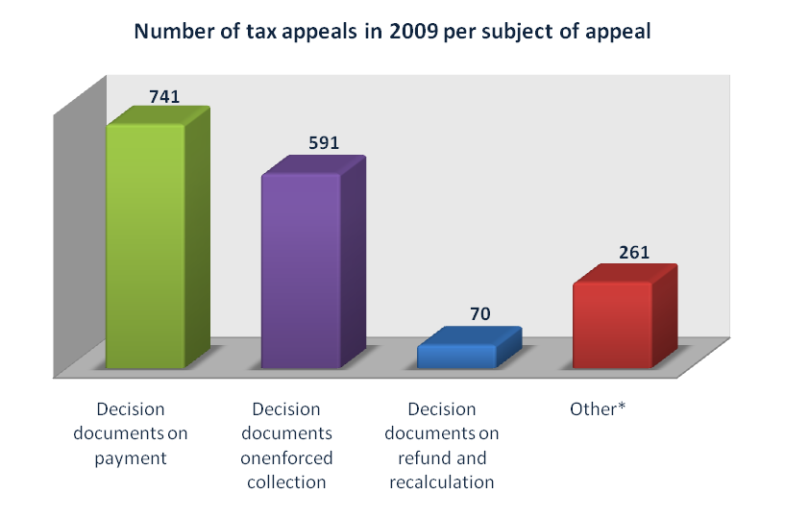
  - Refunds, Transfers, and Corrections
509 decision documents on tax refunds have been issued in 2009 for the amount of 1,07 million KM. 486 of these were effectuated by TA RS, 32 by competent municipalities, and 9 by extra-budgetary Funds.
All records pertaining to refunds are recorded and managed in the Financial Information Management System (SUFI) operated by the Central Tax Documentation Processing Sector. 56.792 decision documents on personal income tax refunds were entered into SUFI in 2009.
Additional 34.518 orders were processed in reference to various transactions related to corrections arising from administrative and other procedures. Transaction processing implies formal and substantial control of documentation pertaining to corrections, including data regularity and analysis relative to current status of records.
  - Information Technologies
2009 was a very dynamic year in information technologies arena in terms of design and redesign of software applications, maintenance of IT system, and other activities. In addition to regular and planned activities for 2009 for the Sector, several additional projects were undertaken due to new legislation being issued, as well as other external factors impacting the work of Tax Administration.
Design, redesign, and maintenance of software applications and services
New software application was released in 2009, the so called DRPN - application used for managing changes to enforced collection deposit account. Tax liabilities collected in enforced collection and payments made in line with rescheduled debt are deposited to this account.
As planned, a new module for electronic returns protocol was developed and released, whereby returns are recorded in the protocol immediately upon receipt and bar coding of hard copies. The module provides a precise overview of the number of returns received and pending for entry in local offices.
Another IT Task Team was heavily engaged in development and implementation of the Fiscal Real Estate Registry and tax billing system as support to implementation of the new Law on Real Estate Tax. Applications were also developed for entry of real estate sales contracts and registration forms, including the module used for field real estate data entry performed by mobile teams.
In addition to new applications, efforts were invested to continuously redesign and enhance current applications (KUP, KOR, PP-KV , FISKAL, etc.), in order to eliminate certain flaws and simplify the use of it.
In support of the fiscal cash register system, we have, in December 2009, initiated the development of the daily reporting system to be used by companies in charge of maintenance of fiscal cash registers.
Throughout the year we have constantly amended and improved our internal and external web sites, which did not go by unnoticed. Namely, the professional jury of the “Mobile Info” Magazine proclaimed our web site the winner in BiH, in 2009, in the “public administration” category.
In the segment of taxpayer services we have introduced certain improvements to our e-filing system. To that extent we have readjusted tax return forms to enable easier and automated completion, saving, and printing, which has significantly simplified the entire process for our taxpayers.
User Support
Large number of support requests, both from internal and external users of the TARS information system, was received in 2009, primarily regarding the field installation of the E-Filing Program for Taxpayers (PPO) for the monthly withholding income tax return (more than 100 installations).
We have significantly exceeded the 2009 plan in this segment, which will continue to be a priority considering the start of implementation of the Unified System for Registration, Audit, and Collection of Contributions, as well as due to development of new ones and changes being made to existing software applications used by this System.
Infrastructural interventions and equipment/system components maintenance
Infrastructural interventions in 2009 pertain to improvements in the functioning of information-communication technologies in TARS. We have successfully realized the idea on mobile access to TARS Network using portable computers, as well as the mobile teams project pertaining to data entry. In addition, we have enabled a very efficient communication with several external institutions.
Also, multiple savings were accomplished through introduction of VMWare software, which enables the option of using a lower number of physical servers to obtain a much higher number of functional server units for multiple uses.
  - Cooperation with other institutions/agencies
We have had a more intensive cooperation with the RS Ministry of Finance in 2009 in the sense of exchange of information. Respectively, we have expanded the set of reports provided to Ministry of Finance (Fiscal Analysis Unit), including the new, experimental technology of multimedia dynamic reports. We have also enabled the Ministry of Industry, Energy, and Mining and the RS Statistics Bureau to access our intranet.
In addition, we have entered into several agreements on cooperation (e.g. with RS Bureau of Statistics, regarding the exchange of information, and with RS Chamber of Commerce). We are currently negotiating the exchange of information with other institutions as well, in order to secure uniform data, which is of importance to Tax Administration, as well as to other institutions.
In 2009, we have had extensive cooperation with USAID TARA with respect to realization of the new real estate tax system, and with USAID ELMO regarding the application of new, Unified System for Contributions.
We held several meetings throughout 2009 with representatives of various institutions and projects:
- ICITAP – financial investigations and tax evasion,
- OECD – fiscal and information policy at the level of economic analysis and exchange of experiences,
- RS Ministry of Finance – settlement of debt via bonds, and partial write-off of receivables,
- RS Health Insurance Fund – harmonization of records on taxpayers liabilities for taxpayers with debt reschedule agreements,
- Water Agency for Sava River District – collection of water charges.
Tax Administration representatives have attended the 13th General Assembly of IOTA – Intra European Organization of Tax Administration, held July 09-14, 2009 in Stockholm. Top management of 45 European tax agencies have discussed the topic of “The Fight against Fraud – Successful measures adopted by tax administrations to tackle tax fraud taking into account limitations imposed by data confidentiality”“.

Tax Administration of Republic of Srpska was accepted as a full member of the Intra-European Organization of Tax Administrations (IOTA) at the 8th IOTA General Assembly, held June 14-16, 2004 in Prague.
www.iota-tax.org
- TARS representatives also took part in 4 Area Group meetings organized by IOTA (Taxpayer Education and Services, and Large Taxpayers Treatment and Audit),
- Three Workshops (E-Audit, intermediate and advanced level, Use of Information in selecting taxpayers for audit at risk), and
- Two IOTA Principal Contact Persons Forums.
  - Media Appearance
RS Tax Administration needs public support. In order to gain it, we need to have the public understand our role, responsibility, and function, which is attained through transparency in work and application of the provisions of the Law on Free Access to Information.
Our media campaign in 2009 was focused on the start of implementation of the Unified System for Registration, Audit, and Collection of Contributions and continuation of the process of introduction of fiscal cash registers, as well as registration of real estate with the Fiscal Real Estate Register.
Data presented in the following table provide an overview of media appearances of Tax Administration representatives:
# | Media Appearance | 2009 | 2008 | Index  09/08
1. | Reply to Inquiry | 146 | 30 | 487
2. | Statements via telephone | 51 | 13 | 392
3. | Press Releases | 65 | 12 | 542
4. | Official Denials | 5 | 42 | 12
5. | TV Shows | 31 | 47 | 66
6. | Information | 192 | 7 | 2.743
7. | Interviews | 78 | 15 | 520
8. | Public communiqués | 28 | 1 | 2.800
9. | Press Conferences | 4 | 4 | 100
10. | E-mail replies | 20 | 0 | -
11. | Press articles | 58 | 0 | -
TOTAL |  | 678 | 171 | 396
In 253 working days in 2009, we have had 678 media appearances, i.e. more than two appearances per working day.
- SUMMARY
In retrospect, we can be more than satisfied with the results we have achieved in 2009 in terms of both, the collection of public revenue under our competence and the improvement of other areas of work, particularly so, if we take into consideration the economic downfall in 2009, which had an adverse impact on collection of public revenues.
Despite the difficulties, we have managed to increase the rate of public revenue collection, relative to 2008, by 5%, whereas the overall percentage of realization of our 2009 Collection Plan is 98%. Respectively, significant increase was achieved in the category of social contributions, where collection rate was higher by 15% relative to 2008, with plan realization level at 99%.
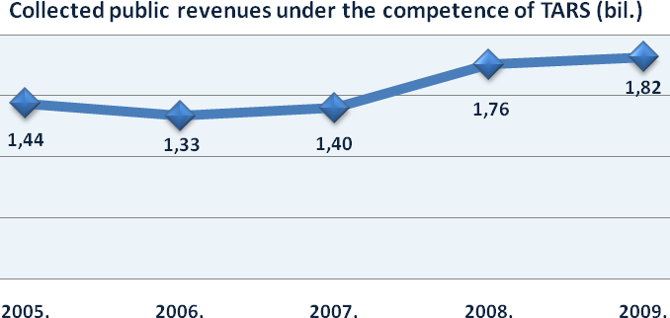
We have continued to implement planned activities related to the project of introduction of fiscal cash registered, initiated back in 2008 in line with the Law on Fiscal Cash Registers. We have officially completed this process on 15 August 2009, which was the deadline for fiscalization of the third group of taxpayers. By 31 December 2009, we have received 40.347 requests from taxpayers for initial fiscalization, and have issued 39.678 decision documents respectively (98,34% of the total number of filed requests).
Numerous activities have been undertaken in regards to the establishment of the Fiscal Real Estate Register. Although real estate registration deadline has been extended through March 2011, we have continued with planned activities and have developed a software application for registration of real estate sales contracts and entry of real estate registration forms, including the application for field entry of real estate performed by mobile teams.
Our media exposure was at a high level. We have used electronic and printed media to continuously inform taxpayers on current changes in tax regulations and other tax related issues, thus aiding greatly our efforts conducted in the field of taxpayer education.
Significant improvements were made in terms of our internal procedures. Namely, we have completed and issued two internal instructions, the first one being the „Methodological Instruction for Audit“, which enables uniform and standardized procedure in taxpayer audit. It provides guidance related to audit planning, as well as general provisions and audit procedures for different types of revenues subject to Tax Administration audit. The second one is the „Methodological Instruction for Enforced Collection“ providing standardized guidance for enforced collection, aiming at higher efficiency in the process.
RS Tax Administration, being in charge of collection of public revenues and implementation of legislation, and acting as service to taxpayers, shall continue to consistently, efficiently, and impartially implement all laws pertaining to its scope of work and improve the quality of services provided to taxpayers, including the provision of timely information to the public on all current affairs of the Tax Administration.
TAX ADMINISTRATION OF REPUBLIC OF SRPSKA
45-47 Mladena Stojanovića Street
78 000 Banja Luka
Tel: +387 (0)51 332 300 Fax: +387 (0)51 332 336
http://www.poreskaupravars.org
Е-mail: kontakt@poreskaupravars.org
Voice Mail (Call Center): +387 (0)51 345 080

